- Troubleshooting Network Services Practical

Q1. Simulate a DNS resolution failure on your local machine by editing the hosts file to point www.spotify.com to a wrong IP address, then try to ping the domain and document the error message you receive?

Answer
To simulate a DNS resolution problem, I edited the Windows hosts file and manually mapped www.spotify.com to an incorrect IP address.
- I added the following entry in the hosts file:
203.0.113.123 www.spotify.com
- After saving the file, I cleared the DNS cache using:
ipconfig /flushdns
- Then I tested the domain using:
ping -4 www.spotify.com
- The system resolved www.spotify.com to the incorrect IP address 203.0.113.123. The ping failed and displayed:
Request timed out.
The final result showed:
Packets: Sent = 4, Received = 0, Lost = 4 (100% loss)
- Conclusion:
The incorrect hosts file entry caused www.spotify.com to resolve to the wrong IP address. Because the wrong IP was unreachable, the ping request timed out. This demonstrates how an incorrect local hostname mapping can cause a website or domain to become unreachable.
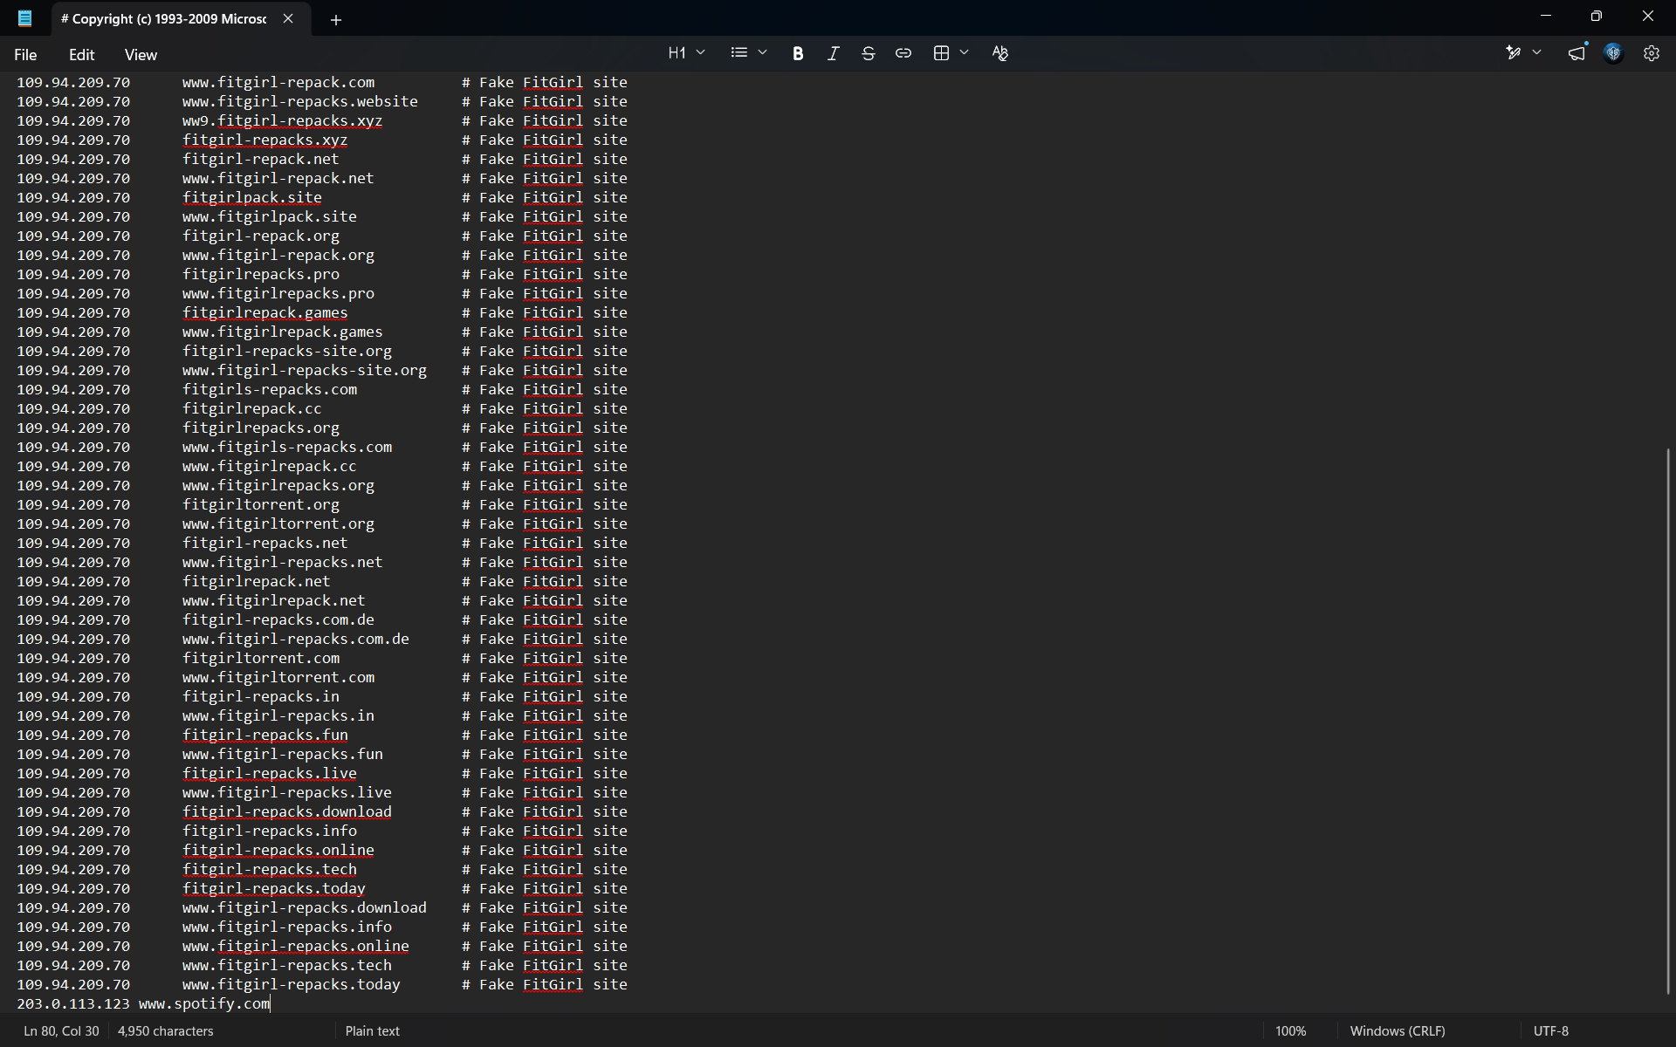
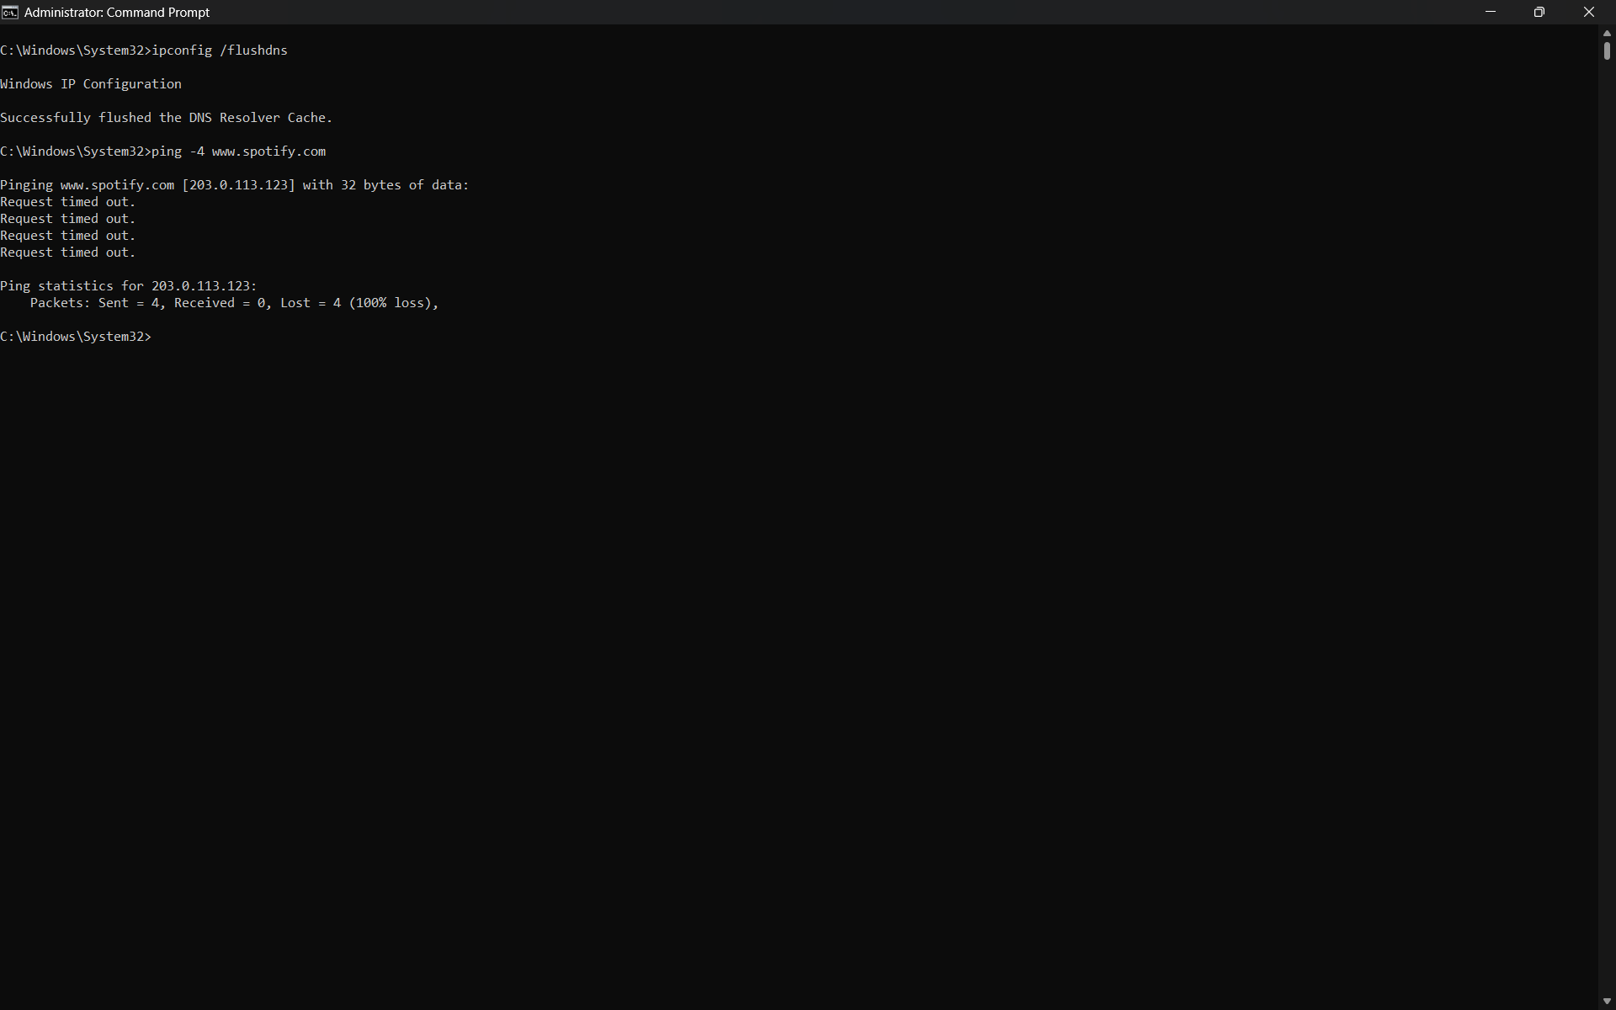

Q2. Configure a DHCP server in a network simulator (such as Cisco Packet Tracer or GNS3) and intentionally set an incorrect default gateway; connect a client device and verify the assigned gateway, then describe how you would identify and fix this issue?

Answer
I created a simple network in Cisco Packet Tracer using one router, one switch, one server, and one client PC.
- The router interface was configured with the following IP address:
- IP Address: 192.168.1.1
- Subnet Mask: 255.255.255.0
- The server was configured with a static IP address:
- IP Address: 192.168.1.2
- Subnet Mask: 255.255.255.0
- Default Gateway: 192.168.1.1
- DHCP Configuration with Incorrect Gateway
- On the DHCP server, I created a DHCP pool with the following settings:
- Pool Name: DHCP-Pool
- Default Gateway: 192.168.1.254
- Start IP Address: 192.168.1.10
- Subnet Mask: 255.255.255.0
- Maximum Users: 20
The gateway 192.168.1.254 was intentionally entered incorrectly. The correct router gateway was 192.168.1.1.
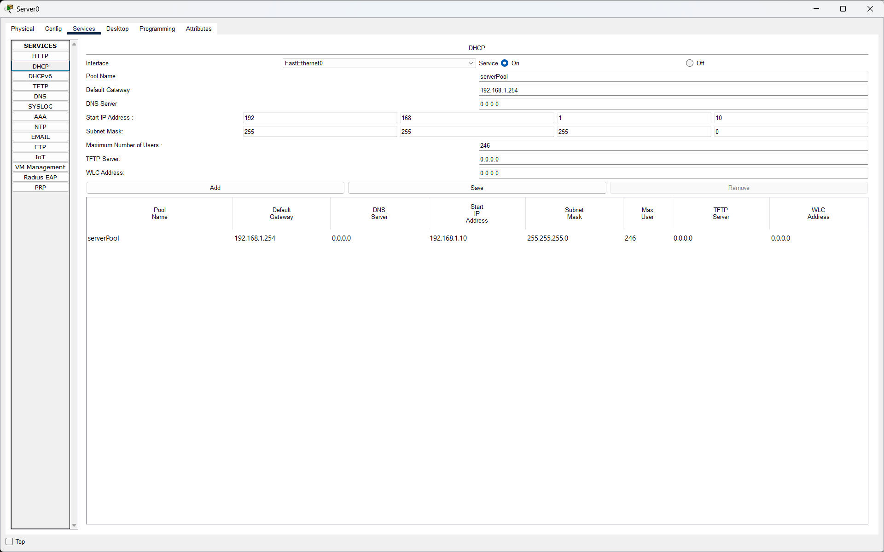
- Server → Services → DHCP
    - It should show:
    - Default Gateway: 192.168.1.254
    - DHCP pool configured with an incorrect default gateway.

- Verification on the Client PC
- The client PC was configured to obtain its IP address automatically using DHCP.
- The PC received:
- IPv4 Address: 192.168.1.10
- Subnet Mask: 255.255.255.0
- Default Gateway: 192.168.1.254
- I verified the assigned configuration using:
    - ipconfig
    - The output confirmed that the DHCP server had given the client the incorrect default gateway 192.168.1.254.

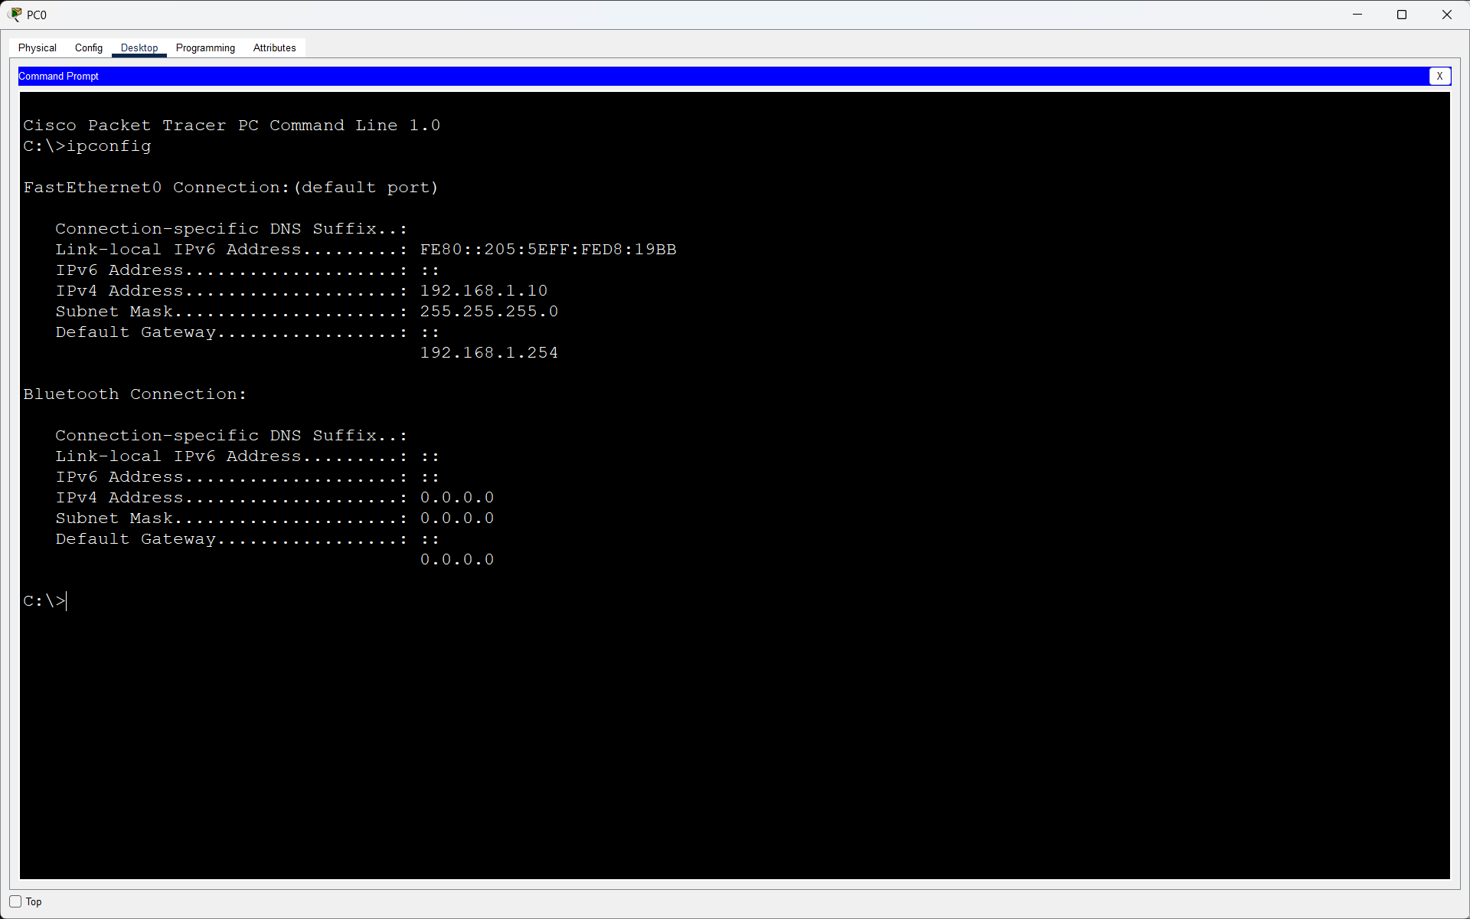
- Client PC received the incorrect gateway from the DHCP server.
Identifying the Problem
To check whether the assigned gateway was reachable, I used:
ping 192.168.1.254
The result showed:
Request timed out.
Packets: Sent = 4, Received = 0, Lost = 4 (100% loss)
This confirmed that 192.168.1.254 was not the correct router gateway.
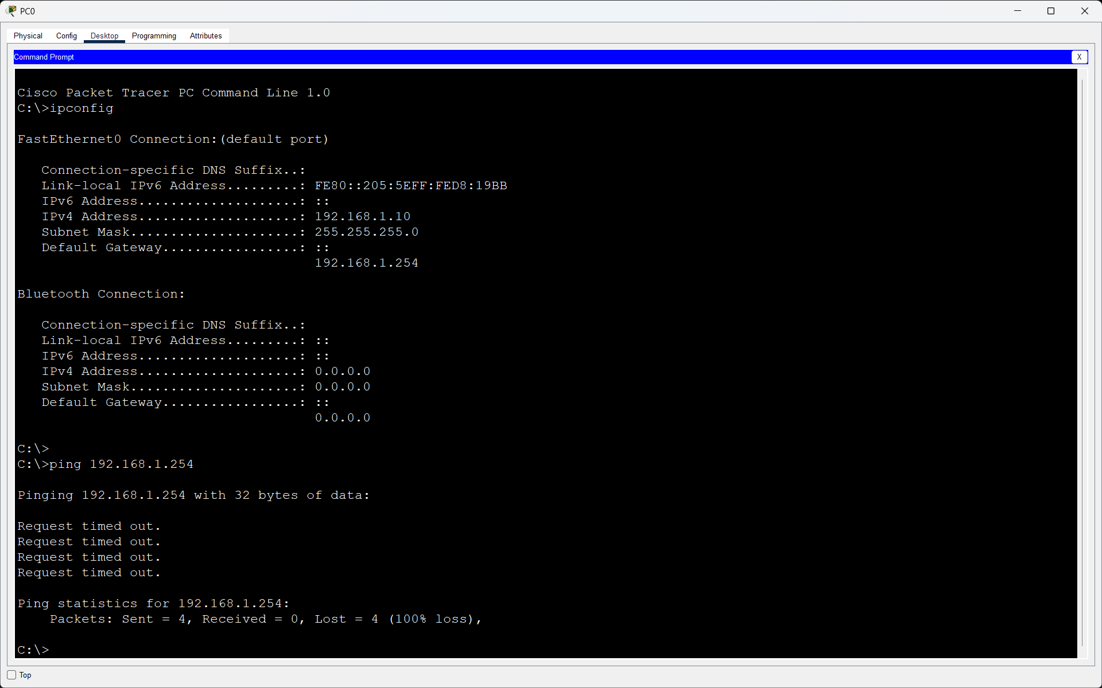
- Fixing the DHCP Configuration
- I opened:
- Server → Services → DHCP
- and changed the default gateway from:
- 192.168.1.254
- to the correct router IP:
- 192.168.1.1
- After updating the DHCP pool, I renewed the DHCP configuration on the client PC.
- The PC then received:
- IP Address: 192.168.1.10
- Subnet Mask: 255.255.255.0
- Default Gateway: 192.168.1.1
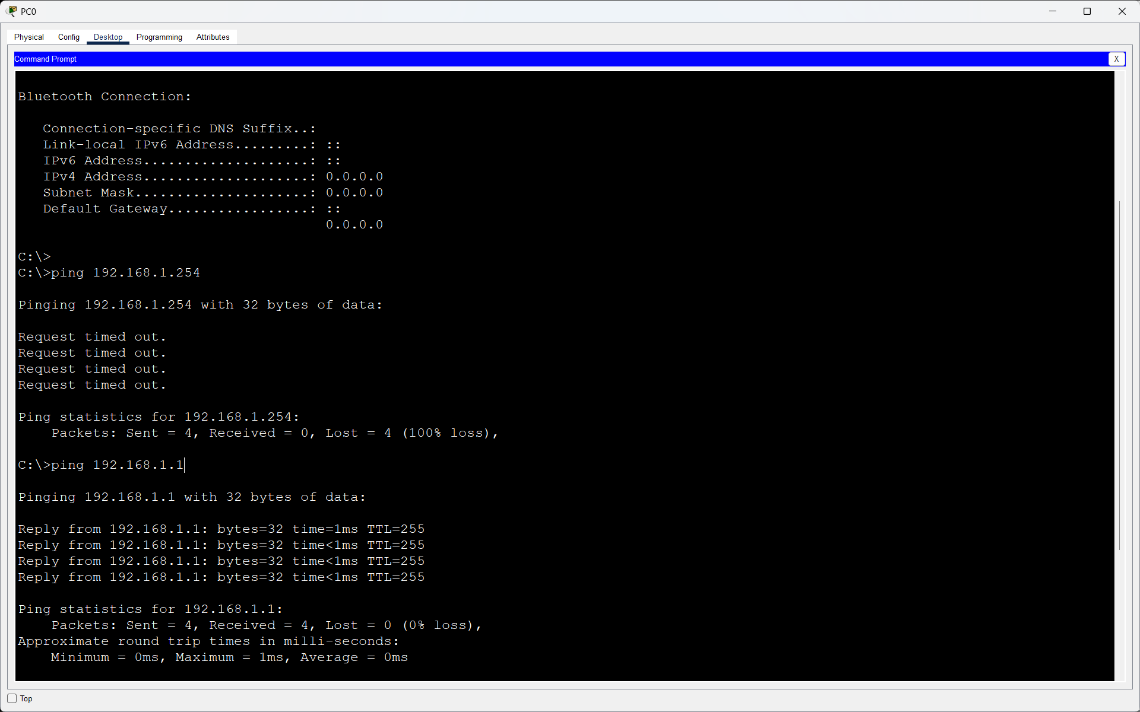
- Final Verification
- I tested the correct gateway using:
- ping 192.168.1.1
- The result showed successful replies:
- Reply from 192.168.1.1
- Packets: Sent = 4, Received = 4, Lost = 0 (0% loss)
- This confirmed that the problem had been fixed.
- Conclusion
The client was receiving an incorrect default gateway because the wrong gateway address was configured in the DHCP pool. I identified the problem using ipconfig and ping. After changing the DHCP gateway from 192.168.1.254 to the correct router address 192.168.1.1, the client received the correct network configuration and successfully communicated with the router.

Q3. Given a scenario where devices on your simulated network are unable to access websites by name but can by IP address, use the nslookup or dig tool to diagnose the DNS problem and write down the troubleshooting steps and solution?

Answer
- If a device can reach a remote IP address but cannot reach the same service by hostname, basic IP connectivity is probably working and DNS should be checked.
- First ping the default gateway to confirm local connectivity.
- Ping a known reachable IP address. If the IP works, the network path is available.
- Run ipconfig /all (Windows) and note the configured DNS server address.
- Run nslookup www.example.com. Check which DNS server is being queried and whether it returns an answer or a timeout/error.
- Test the DNS server itself with ping where appropriate, or verify that the DNS service/server is online and reachable.
- Check whether the DHCP pool is distributing the correct DNS server address.
- Correct the DNS server setting. In a lab, this might mean changing the DHCP DNS field to the intended DNS server or fixing the DNS service configuration.
- Renew the client configuration, run ipconfig /flushdns, and repeat nslookup. Finally test the website name again.
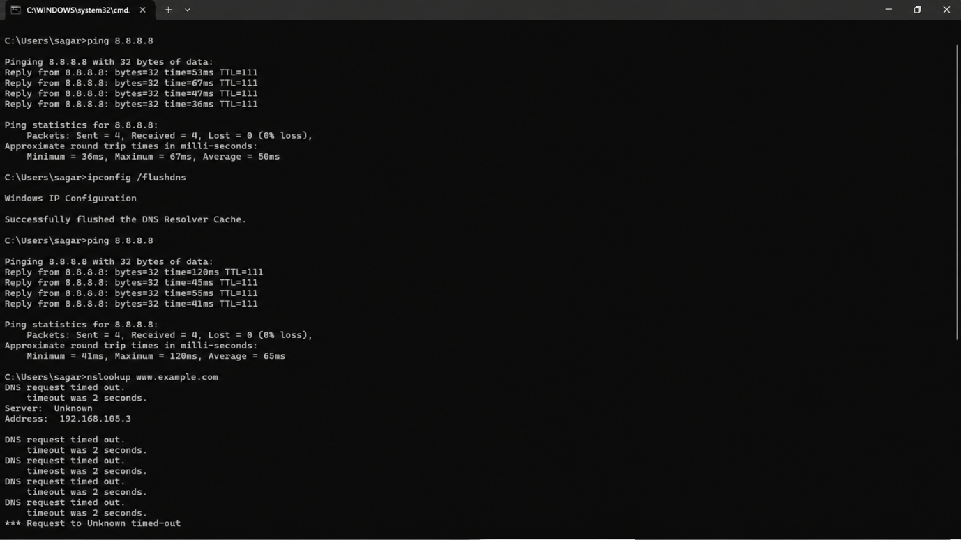
- Solution:
Restore a reachable, correctly configured DNS server and make sure clients receive its address. A successful nslookup should then return one or more IP addresses for the requested hostname.
Q4. A device in your simulated network is not receiving an IP address from the DHCP server and shows an APIPA address (169.x.x.x). List the possible causes for this and document the step-by-step process you would use to resolve it.<br><br><em><strong>Hint:</strong> Check for network connectivity, DHCP scope exhaustion, and server availability.</em>?

Answer
APIPA is used by Windows when a DHCP-enabled interface cannot obtain a normal IPv4 lease. The typical APIPA range is 169.254.0.0/16.
- Possible causes:
- DHCP server is turned off or the DHCP service is stopped.
- Client cable/link or switch port is disconnected/down.
- DHCP scope has no free addresses left.
- DHCP pool has incorrect settings or is not activated.
- Client and DHCP server are on different subnets and no DHCP relay/helper is configured.
- VLAN assignment or trunk configuration prevents DHCP messages from reaching the server.
- Firewall/security settings block DHCP traffic.
- Step-by-step resolution:
- Check the physical/logical link and verify the NIC and switch port are up.
- Run ipconfig /all and confirm DHCP Enabled is Yes and the address is 169.254.x.x.
- Check that the DHCP server is powered on and its DHCP service is enabled.
- Inspect the DHCP scope and confirm free IP addresses are available.
- Confirm the client is in the correct VLAN/subnet. If the server is in another subnet, verify the router DHCP relay/ip helper configuration.
- Correct any pool, VLAN, relay, or connectivity problem found.
- Run ipconfig /release followed by ipconfig /renew, or request DHCP again in Packet Tracer.
- Verify that the client now receives a valid IP address, subnet mask, default gateway, and DNS server.
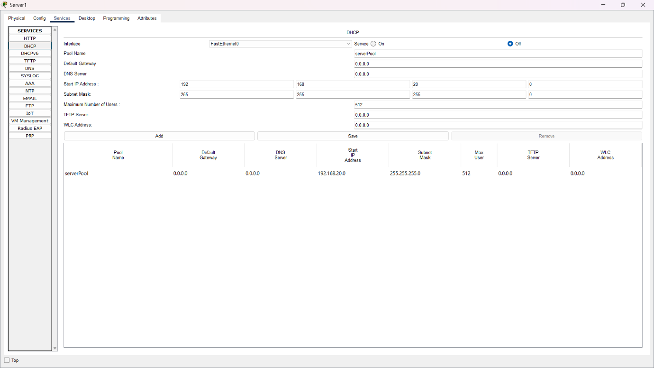
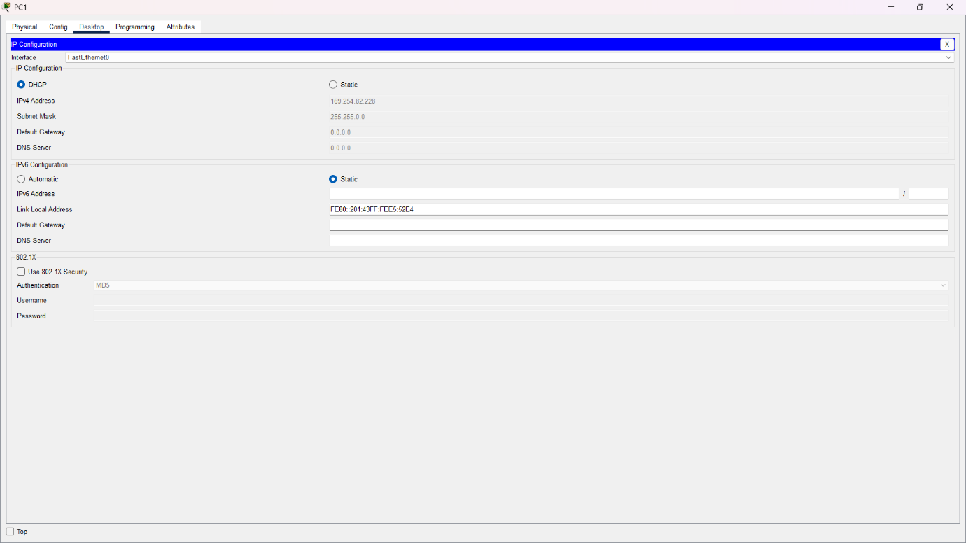
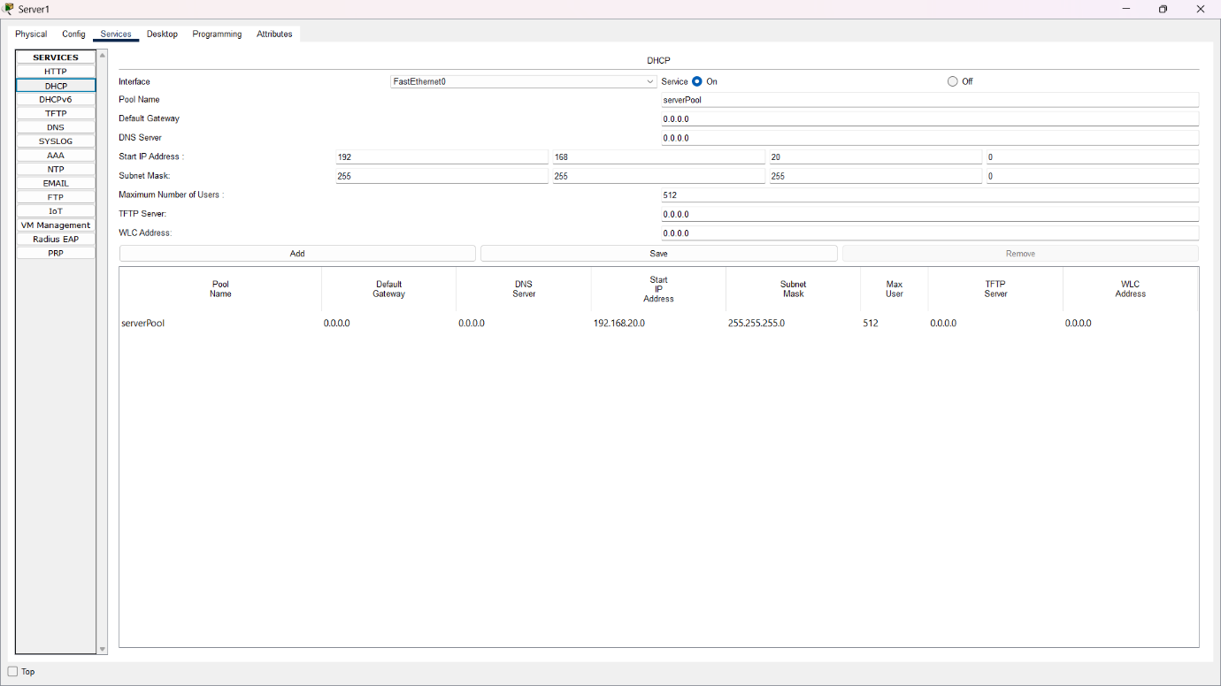
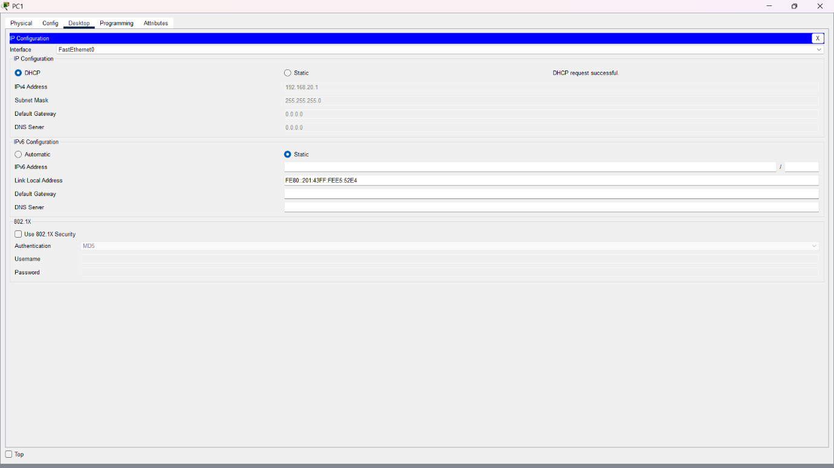

Q5. Create a table documenting at least three common DNS issues and three common DHCP issues you encountered or researched, including symptoms, possible causes, and recommended solutions for each?

Answer
Type | Issue | Symptoms | Possible Cause | Recommended Solution
- DNS | Wrong DNS server | Websites fail by name; IP connectivity may still work. | Incorrect DNS address from DHCP or manual settings. | Set the correct reachable DNS server, renew settings, and test with nslookup.
- DNS | Bad hosts-file entry | One specific domain resolves to an unexpected IP. | Manual hosts-file mapping overrides DNS. | Remove/correct the hosts entry and run ipconfig /flushdns.
- DNS | DNS server/service unavailable | nslookup times out or reports server failure. | DNS service stopped, server unreachable, firewall, or network fault. | Check server/service status, connectivity and firewall; restart/fix DNS service and retest.
- DHCP | Incorrect default gateway | Client gets an IP but cannot reach remote networks. | Wrong gateway configured in DHCP scope. | Correct the scope gateway and renew the client lease.
- DHCP | Scope exhausted | New clients fail to obtain a lease or may use APIPA. | All addresses in the DHCP pool are already leased/reserved. | Expand/adjust the pool, remove stale leases where appropriate, or reduce lease duration in a lab.
- DHCP | DHCP server unreachable | Client receives 169.254.x.x and renew fails. | Server/service down, link/VLAN problem, or missing relay across subnets. | Restore connectivity/service, verify VLANs and DHCP relay, then renew the lease.

- Conclusion
This practical demonstrates common DNS and DHCP failures and a simple troubleshooting method: verify connectivity, inspect the client configuration, test the relevant service, compare expected and actual settings, correct the configuration, and test again. DNS mainly affects name-to-IP resolution, while DHCP supplies client addressing information such as IP address, subnet mask, gateway, and DNS server.

